Multiple-choice section – choose the correct answer

Question 1 [3.1]

What is the expansion of ?

A 3a + 5 B 3a – 5 C 3a + 15 D 15

Question 2 [3.1]

Expanding the expression b(2b – 4) gives:

A b2 – 4b B 2b2 – 4b C 2b2 – 4 D 2b – 4b

Question 3 [3.1]

Expanded, the expression  is:

A  B  C  D 

Question 4 [3.2]

The highest common factor of and is:

A  B 3 C  D 

Question 5 [3.4]

The dilation factor of y = 4(x + 5)2 − 1 is:

A 5 B 4 C 2 D 4

Question 6 [3.4]

To sketch the graph of y = (x – 1)2 – 3, the graph of y = x2 needs to be translated:

A 3 units to the right and 1 unit down. B 1 unit to the left and 3 units down.

C 3 units to the left and 1 unit down. D 1 unit to the right and 3 units down

Question 7 [3.1]

When expanded (x + 3)(x + 2) is:

A x2 + 5x + 6 B x2 + 6x + 5 C x2 – 5x + 6 D x2 + x + 5

Question 8 [3.6]

When k2 – 25 is factorised, it is:

A (k + 25)(k – 1) B (k + 5)(k – 5) C (k2 + 5)(k2 – 5) D (k – 5)(k – 5)

Question 9 [3.7]

By cancelling,  simplifies to:

A 50 B 20 C 3 D 4

Multiple-choice total marks: __ / 9

Short answer section

Question 10 2 marks [3.2, 3.5]

Use words from the list below to complete the following sentences.

factorising algebraic fractions perfect squares monic

difference of two squares highest common factor quadratic trinomial binomial product

(a) HCF is an abbreviation for____________________________________.

(b) The expression  is a _____________________________________ because it has three terms and the highest power of x is 2.

Question 11 2 marks [3.2]

Explain the term ‘factorising’. Use 14ab + 10a to help you explain.

Question 12 3 marks [3.1]

Show the missing parts of the calculations in the spaces.

4(2g + 5) + 3(2g – 1)

= 4 × __g + __ × __ + 3 × __g + __ × -1

= 8g + ____ + 6g – ___

= __g +____

Question 13 4 marks [3.2]

Jen wishes to factorise the expression 12bg – 6bga.

(a) (i) What is the highest common factor of 12 and 6?

(ii) What is the highest common factor of bg and bga?

(b) What is the highest common factor of 12bg and 6bga?

(c) Factorise 12bg – 6bga.

Question 14 3 marks [3.2]

An expression for the area of the large rectangle is xy.

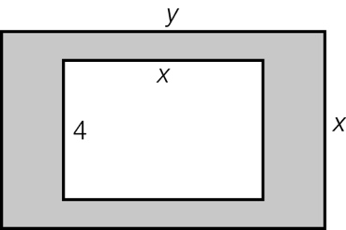

(a) Write an expression for the area of the small rectangle.

(b) Write an expression for the shaded area.   
Hint: Use the areas of the large rectangle and the small rectangle from part **(a)**.

(c) Factorise the expression in part **(b)**.

Question 15 3 marks [3.4]

The graph of is transformed and can now be described by the equation.

State the type of transformation that occurred by each part of the equation given by:

(a) 5

(b) +4

(c) +1

Question 16 4 marks [3.5]

(a) List all pairs of positive whole numbers a, b such that .

|  |  |
| --- | --- |
| a | b |
|  |  |
|  |  |
|  |  |
|  |  |

(b) Which pair of numbers from your list in (a) add to 10?

(c) Use your answers from (a) and (b) to factorise x2 + 10x + 24.

Question 17 2 marks [3.5]

Factorise  (Hint: Which two numbers multiply to give -10 and add to give -3?)

Question 18 4 marks [3.2]

A square area of garden has a side length a metres. The garden has a grassed area and a fish pond of area 4b2 m2, as shown in the diagram.

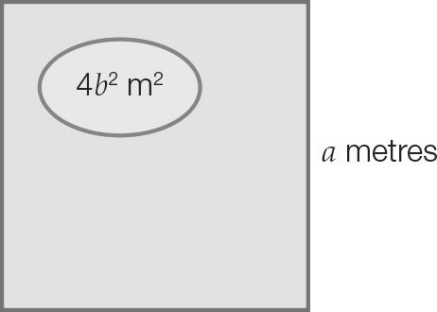

(a) Write an expression for the total area of the garden.

(b) Using your answer to part **(a)**, write an expression for the area of grass.

(c) Factorise your answer to part **(b)** using the difference of two squares method.

Question 19 3 marks [3.7]

(a) Simplify the expression 2a + 13 + 3a – 3.

(b) Factorise your expression from part **(a)**.

(c) Using your answer for **(b)**, simplify .

Short answer total:_________/28

Extended answer section

Question 21 5 marks [3.5]

The height h metres of a ball above the ground at time t seconds after it has been thrown  
 is given by h = -t2 – 3t + 4.

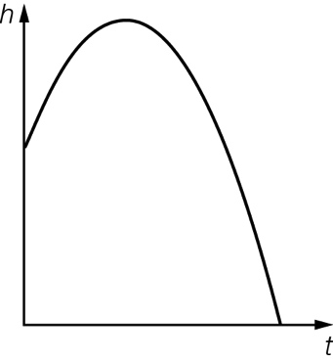

(a) How high is the ball above the ground when it is first thrown (that is, when t = 0)?

(b) Write -t2 – 3t + 4 in factorised form using the cross method. Hint: First write -t2 – 3t + 4 = -(t2 + 3t – 4).

(c) From your answer to part (b), state what positive value of t gives h = 0.

Question 22 10 marks [3.1, 3.2]

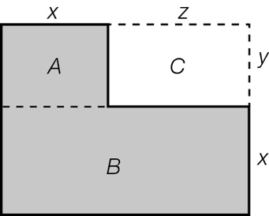The diagram shows part of the floor plan of a house consisting of a kitchen A and a lounge room B.

(a) Write an expression for the area of A.

(b) To find the area of B:

(i) Write an expression for the length of B.

(ii) Write an expression for the area of B.

(c) Find an expression for the shaded area by adding the areas of A and B.  
Write your answer in expanded form.

(d) Find an expression for the area of the large rectangle formed by A, B, C.  
Write your answer in expanded form.

(e) Write an expression for the area of C.

(f) Find an expression for the shaded area again but this time using your answers to parts (d) and (e).  
(Hint: Subtract the area of C from the large rectangle formed by A, B, C.)

(g) Compare your answers to parts **(c)** and **(f)**. What do you notice?

Extended answer total:_____/15

TOTAL test results: ____ / 52